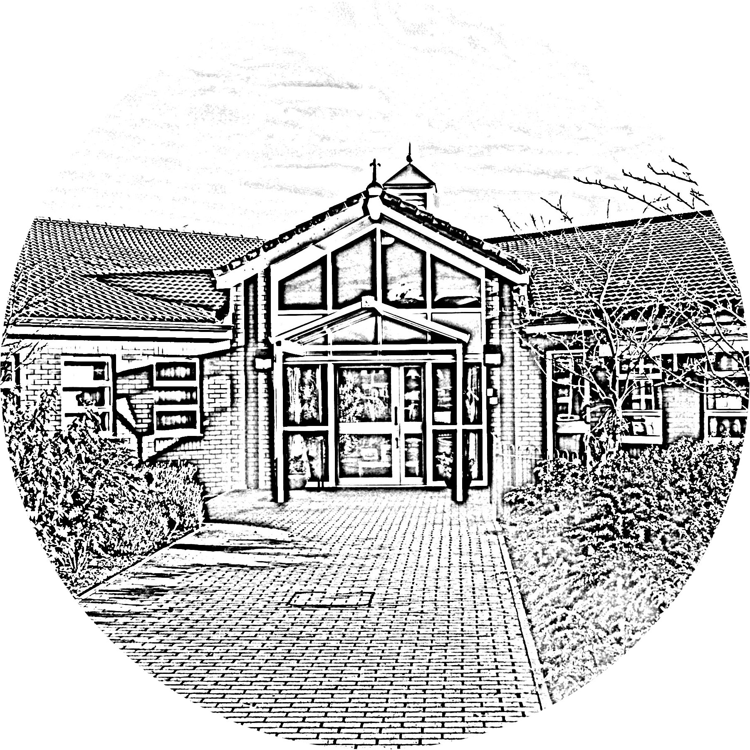

Brookside Primary School
Home Learning Offer

Provision of Learning during the COVID-19 Pandemic
In light of the full school closure, we have updated our Home Learning offer for all children from Nursery up to Year 6.
Whilst Brookside Primary School is closed for the majority of pupils, we continue to offer the full range of curriculum areas through our Home Learning offer. All work is set daily on the class pages of our website. Children from all year groups will be offered a mixture of video-based lessons, eg from Oak Academy, Read Write Inc, White Rose Maths as well as other independent activities that mirror the school day. The quantity and subjects taught via our range of lessons will vary depending on the age and needs of the different year groups. Those children who attend school will be supported by staff in accessing their lessons and working on the online lessons.
Regular live Class Assemblies will take place on Zoom each Monday and Friday at set times for each class:
Class | Assembly Time
Nursery | 10am
Reception | 10:30am
Year 1 | 11am
Year 2 | 11:30am
Year 3 | 1pm
Year 4 | 1:30pm
Year 5 | 2pm
Year 6 | 2:30pm

The Class Assembly will give teachers the chance to see and talk with the children and sort any problems with their remote learning tasks etc. In addition, teachers may use the time to read a story or do other useful, appropriate activities and have a good catch-up. The children have the chance to refocus on school, reconnect with their teachers and peers, and hopefully find motivation, especially those who are struggling in the lockdown, so supporting their mental wellbeing. We have advertised expected protocols for live sessions as they pertain to teachers, pupils and parents on our Facebook page and on our website.
Parents know their children best so we encourage our families to set their own routines, timetables and systems to best fit their own unique circumstances. Class teachers are always available to meet virtually or have a phone conversation with parents to support in any way we can. As a general rule however, having maths and literacy learning in the morning (with a break in between) then working on the curriculum topic in the afternoon would mirror the daily experiences of the children in school.
We love to celebrate our children’s home learning achievements by posting work or pictures submitted onto our school Facebook page. We will always seek parental consent first.

Frequently Asked Questions
How can I communicate with my child's teacher?
Teachers, SENCO and Pastoral Manager will be contacting parents regularly throughout the half term to see how home learning is going. This will be a chance to discuss your child’s wellbeing as well as the learning from that week and any other questions you may have. This is also a great opportunity for teachers to offer support in adapting the learning to suit the needs of your child. If you do not require a weekly phone call, teachers can arrange a schedule of phone calls to suit individual families’ needs. Teachers are available to contact through their school email accounts:
Nursery | s.mcdonald@brookside.cheshire.sch.uk
Reception | a.loney@brookside.cheshire.sch.uk
Year 1 | j.smith@brookside.cheshire.sch.uk
Year 2 | a.gambles@brookside.cheshire.sch.uk
Year 3 | s.lomas@brookside.cheshire.sch.uk
Year 4 | t.hartley@brookside.cheshire.sch.uk
Year 5 | d.orme@brookside.cheshire.sch.uk
Year 6 | d.whitcombe@brookside.cheshire.sch.uk

I have more than one child at home, how do I manage the lessons?
All lessons are saved on the class pages of the school website and can be accessed at a time which is convenient to the children in the household. Live class sessions on Zoom are staggered across the school day to support families with more than one child.

I am struggling to fit in all of the Home Learning lessons, are there any lessons I should prioritise?
We completely understand that all families have different circumstances as well as differing responsibilities to juggle. If children need to prioritise lessons, we would suggest that both English and Maths lessons are completed. Please speak to your child’s class teacher to help support with prioritises and individual needs.

Will my child’s home learning be marked?
All work should be submitted to class teaches via their school email addresses and individual feedback will be provided. However, in order to support parents, answers to set work will often be provided too. If parents wish to mark the work themselves where answers are provided, this is fine and should be submitted to the teacher via email to contribute to teacher assessment judgements.

I don’t have enough technology at home, what do I do?
We have received a number of devices from the DfE which we are able to loan out to parents during this time. We have also received some donations of unwanted laptops from members of our community. Please get in touch with the school office who will be able to support you with your technology issue.

What do I do if I'm concerned about my child?
Please speak to your child’s class teacher about any concerns that you have. They will be able to help you or alternatively they could advise which other member of our team could help. Our Pastoral Team is on hand to support our families with any needs that arise.

My child has specific needs and I would like more support?
Our Pastoral Team is on hand to support you with any questions you may have. They are able to offer a variety of ways to support your child, including scheduled catch ups, help with work and strategies to support children’s mental health. Our Pastoral Team consists of our Inclusion Manager (SENDCO) and Learning Mentor.

Additional Learning Resources
In addition to this provision, below you will find a list of useful resources that you can draw on at any time to support your child’s learning at home.

Nursery & Reception
Starfall - Where Children Have Fun Learning to Read
Cool Math 4 Kids – Maths games for kids teachers and parents
Unite for Literacy – Free ebooks with narration
Literactive - Provider of reading material for nursery and reception aged children
Kids Learning Tube

Years 1 & 2
Starfall - Where Children Have Fun Learning to Read
PBS Kids - Games, Videos and Activities
Cool Math 4 Kids – Maths games for kids teachers and parents
Unite for Literacy – Free ebooks with narration
Sci Show Kids
National Geographic Kids
Free School on YouTube
Geography Focus
Science Max

Years 3 - 6
Pretend to travel the world... Go on a virtual tour of these 10 famous museums.
Free e-copies of the children’s Newspaper First News (activities available on their website)
Science Kids – Fun Science and Technology for kids (including practical experiments!)
Cool Math 4 Kids – Maths games for kids, teachers and parents
National Geographic Kids
Crash Course Kids
Geek Gurl Diaries

All Year Groups
Scholastic - Day-by-day projects to keep kids reading, thinking, and growing.
Funbrain - Games, books, comics, and videos that develop skills in math, reading, problem-solving and literacy.
Mathsbot - Maths puzzles

